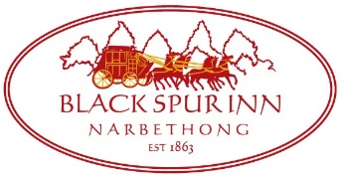
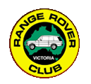
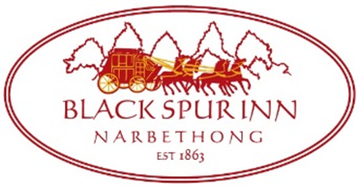
RANGE ROVER CLUB TAKEAWAY MENU
SATURDAY 11TH DECEMBER, 2021

SOMETHING LIGHT
Garlic Bread $9 / with Cheese $10
Fries with your choice of aioli, gravy tomato sauce dipping sauce $8.5
Spiced Haloumi Fries with a yoghurt & herb dipping sauce $14
Spanish Pulled Pork Croquetta’s, chipotle aioli $14
Satay Chicken Skewers with mild peanut sauce (3) $22

SALADS
Quinoa Salad of sweet potato, cherry tomato, raisins, mixed seeds, diced capsicum, feta cheese, pomegranate & olive oil dressing $19 (gf) (v)
Buxton Smoked Trout Salad with coleslaw, peanuts & wasabi aioli $22

COUNTRY CLASSICS
Panko Crumbed Chicken Breast Parmagiana, ham, Napoli sauce and cheese with fries & salad $26
Panko Crumbed Chicken Breast Schnitzel with fries, salad & choice of sauce $24
Black Spur 180gr Wagyu Beef Burger with bacon, caramelised onion, tomato, cheddar cheese, tomato relish & fries $25
Beer Battered Fish'n'Chips, house salad, lemon and tartare $24.5 (gfa)
Salt & Pepper Calamari, lime aioli with fries and salad $25 (gf)

PASTAS
Lentil Bolognese with vegan penne pasta $25 (veg)
Pumpkin Gnocchi with a wild mushroom sauce $25 (v)

